**Hey Rehber REV4**

**Admin Panel**

We add theseto the left side bar

1. **Help Desk - Main**
   * 1. Tickets - Sub
     2. Ticket Categories - Sub

TICKETS LISTING

|  |  |
| --- | --- |
| id |  |
| Ticket ID | IF guide starts with GU, if agency starts with AG |
| Subject | Title with link to ticket details |
| Category |  |
| Submission date |  |
| From | Guide name or agency name |
| Status | New, Replied by Agency, Replied By Guide, Replied By Admin, Closed |
| Last updated |  |
| Actions |  |

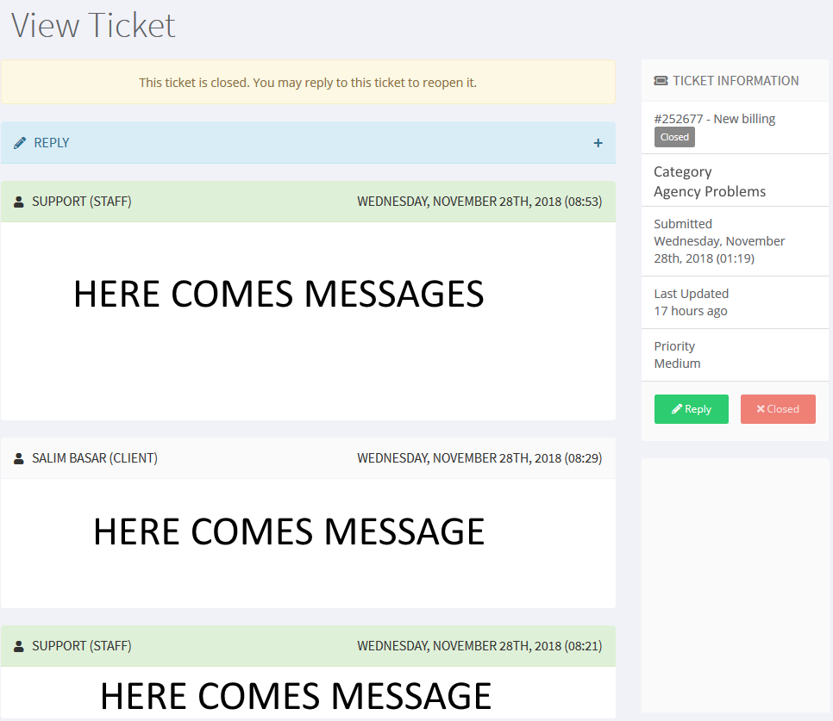

Ticket Details page will be same for admin, Guide and Agency. Only for admin can have some difference things. We will show attachement as link.

**Guide Panel**

1. Help Desk - Main
   * 1. My Tickets - Sub
     2. New Tickets - Sub

TICKET ADDING FOR THE GUIDE OR AGENCY

|  |  |
| --- | --- |
| Subjet |  |
| Categories | Choose from dropdown |
| Priority |  |
| Message |  |
| Attachments |  |

**AGENCY PANEL**

1. Help Desk - Main
   * 1. My Tickets - Sub
     2. New Tickets - Sub

|  |  |
| --- | --- |
|  | This is an example that we will have  Subject,  Categories,  Priority,  Message  Attachements |